Thursday, May 23, 2024
11:00 am – 1:00 pm, Central
Supporting Children Who are Gender Fluid
This training will help participants understand the ways that children develop their gender identity. A focus will be given on understanding diverse identities beyond the binary notion of gender. Beyond this foundational information, we will discuss ways to support children who are gender expansive in early educational settings. Using children’s literature to support inclusive and welcoming spaces will also be explored.

Speaker:
Erica Schepp, M.S.E.
Wisconsin Early Childhood Association
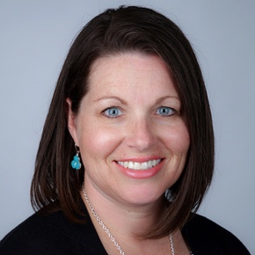
Erica Schepp holds an undergraduate degree in Early Childhood Education from the University of Wisconsin-Whitewater and a master’s degree in education with an emphasis on Curriculum and Instruction. She is a former teacher in various Kindergarten - 3rd grade classrooms. While employed at UW-Whitewater for 16 years, she held various roles as an adjunct instructor of both undergraduate and graduate courses, a supervisor of teacher candidates in the Early Childhood Education program, and as the Director of the Children’s Center for 10 years. Currently, she is the Professional Development Navigator for the Wisconsin Early Childhood Association. She is passionate about social justice work in Early Childhood settings, focusing on issues involving gender equity and LGBTQ+ advocacy. She lives with her family in Whitewater, Wisconsin.
Disclosures:
Financial – Erica Schepp is employed by the Wisconsin Early Childhood Association and receives a salary.
Non-financial – No relevant disclosures exist.
Learning Objectives:
- Define gender identification and gender expression.
- Discuss current terminology and language related to gender, gender identity, and gender expression.
- List strategies to support young children who are gender expansive in educational settings.
